Using this report to support your child’s progress and well-being

Teenagers can often be reluctant to talk about school with parents/carers. Hopefully these tips and questions can act as a platform for purposeful communication between children and parents. This might already be taking place in your household but for some of us we may need a helping hand.

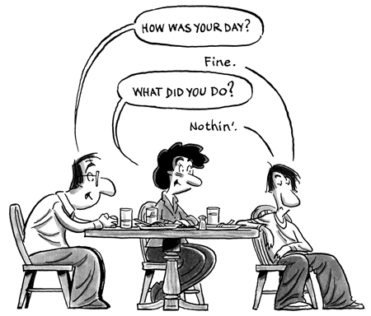

The report contains information about each subject, behavior for learning grades and attendance figures.

Progress in each subject: your child has been given a projected grade. Next to this grade you can see whether s/he is making below, near, good or excellent progress. It can be a challenge to make good progress in all subjects. If your child is below, do not panic, s/he may just need to develop certain skills to get him/her back on track. The class teacher will address all underperformance in the lesson.

Behaviour for Learning: your child is graded on behaviour and attitude to learning in every lesson. Grades 1 and 2 are good; 3 and 4 are a concern as it means that your child is disrupting his/her progress and possibly that of his/her classmates.

Attendance: the graph in the report provides information on your child’s attendance so far this academic year. Good attendance + hard work = good progress.

Home Learning grade: homework should support and develop learning that has taken place in the classroom. Your child should be aiming to get a grade A for home learning. This means that s/he is completing homework in full and handing it in on time.

Tips for parents on tackling post report discussions

Read it, absorb it, take a break

Ask your child what s/he thinks about the report

Focus on the positives

Avoid comparing your child with his/her siblings

Praise effort

Go out for a walk with your child rather than having a face to face conversation

Questions to help steer a positive conversation

How do you think you have done?

What do you think about the report?

What do you think is the most positive part?

Which part are you pleased with?

Can you explain it to me? What do the grades mean?

What could we do together to improve?

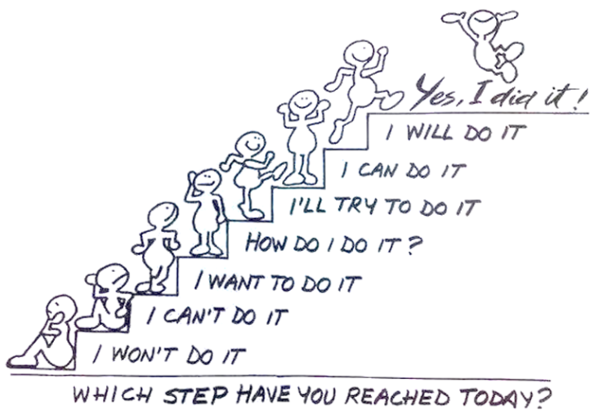
What could we do together to make it more enjoyable?

What has been the most fun?

What has been the most challenging?

How could you behave differently?

Which subject has gone the best? Why?

How do you feel in class? Why?

What skills are you developing?

What extras are you doing outside of the classroom?

Are your option subjects what you thought they were going to be? (Y9)

How do you feel in class?

“Challenges are what make life interesting, overcoming them is what makes life meaningful!” (Joshua J. Marine)

It can be a real challenge to put extra effort into lessons where you feel a bit anxious and it can be easy to try hard in subjects where you feel happy. Emotions are an extremely important part of our lives. Acknowledging our emotions and learning how to manage them can help us to meet important goals.

Think about subjects where you have a strong emotion. Can you set yourself a small target that would help you deal with that emotion? It may be related to feedback your teacher has given to you in a lesson or in your exercise book or it may be a target which focuses on an aspect of your behavior. If the emotion is a positive one, what target can you set yourself that further develops your learning in that subject? You may wish to set a target for a subject without saying what emotion you are feeling – that’s ok!

Emotion | Subject | Target
Happy

Encouraged

Reassured
(it’s ok to get it wrong)
Worried

Other?

I don’t want to put an emotion

There’s more to learning than just grades

It is important to have down time. Make sure that you are eating and drinking healthily. Avoid sugary drinks and foods and make sure that you are getting plenty of exercise. This will keep your mind healthy. It is really important to get into good habits as soon as possible. You may have heard people talk about work/life balance.

Do you:

Exercise at least two times a week?
Go for a walk with a parent/carer?
Go for a walk with a friend?
Read for pleasure?
Have a hobby?
Get fresh air every day?
If not, why not?!!

If you need extra help in a subject contact your class teacher. If you need to talk to someone about school issues in general, contact your form tutor or your Head of College

Waiting for it to happen?

Or making it happen?

